Inductance is a property in which an electromotive force (emf) is generated in it and any nearby conductors. The basis for induction is from Oersted’s and Faraday’s laws, which state that a current causes a magnetic field and that changing magnetic field strength creates an emf. The coupling of these two equations is done through Lenz’s law. This law states that a changing current through a conductor induces a voltage in the opposite direction. The symbol L is used to represent inductance, and its defining equation is given as **[Equation 1]**.

[1]

$$L=(μrμoN^2A)/l$$

Where $μr$ is the relative permeability of the core, $μo$ is the permeability of free space, and N is the number of turns of coil. The cross-sectional area of the solenoid is A, while the length of coil mass is l. Varying these variables independently allows for linearization and verification of the equation.

The first goal of the lab is to verify this equation just as described above. The experiment setup composed of wooden dowels of two different thicknesses. Each of the wooden dowels had copper wire wrapped around it. The number of coils, cross-sectional area, and length of coils were recorded. Removing insulation from the leads at the end of the coil allowed us to connect each end to the leads on an LCR machine to measure inductance. Measurements were taken at 100Hz, 1kHz, and 100kHz. Three points were taken at each frequency to average. These readings were done again while keeping length constant but changing the numbers of wraps of coils (from 10 to 20 to 30). After, the experiment was repeated on a steel rod to find the impact of changing the core material.

Plotting Inductance vs N2 while keeping a constant length and area (and similar material) will give a linear relationship by **[Equation 1]** above. These plots are given in **[Figure 1]**. Our linear regressions all give R2 values of about 0.9 or higher, except for one at 0.81. This means that the squared deviation of the data from a line is very low, and that a linear relationship is appropriate to use. This verifies the above **[Equation1]**.

The equation above can be rearranged to solve for relative permeability. Our relative permeability values for wood and steel with 10 coils and at 100Hz were 0.54 and 1.4x103 deviating from literature values of 1.0 and 9.5x102 by 46 % and 57.9% respectively. This values collected are much higher than expected – sources of error may be from the instrumental error of the LCR meter or random error associated with poor stripping or connections. Furthermore, the setup itself did not lend itself well to the equation – the relationship is better followed with much larger values for N. There was less error as well when frequency was higher.

Though error was large, a linear relationship was still observed. Increasing the number of wraps of coil, N, increased inductance as we expected. Increasing frequency seemed to decrease our inductance, a phenomenon known as inductive reactance. This behavior mimics the reaction to frequency changes that capacitors exhibit, capacitive reactance. It was also determined that steel formed a better solenoid, likely due to its magnetic domains that allowed for magnetic fields to form more easily.

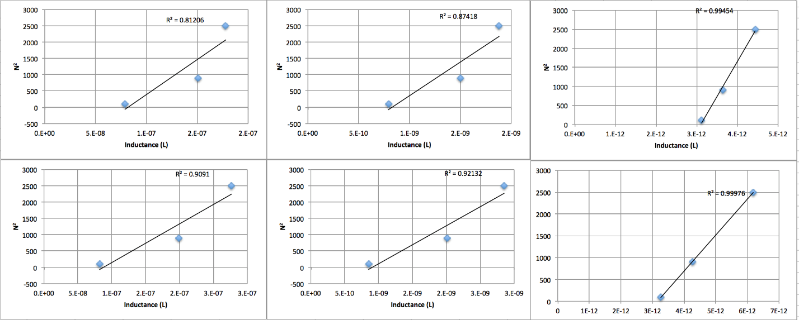

Figure 1: Our Inductance data at different frequencies for each thickness

References:

1. <http://www.engineeringtoolbox.com/permeability-d_1923.html>